Kunal Vora
SHRM Biotechnologies Pvt. Ltd.

Detailed Report on the National Seminar on“Advancements of Biotechnology in Human Welfare”
CONTENT

INTRODUCTION | 3
GOALS & OBJECTIVE OF THE SEMINAR | 3
TARGET AUDIENCE | 3
LIST OF INSTITUTIONS PARTICIPATED | 4
SCHEDULE OF THE SEMINAR DAY | 5
OUTCOME OF INAUGURAL SESSION | 7
TECHNICAL SESSION 1 | 11
TECHNICAL SESSION 2 | 14
TECHNICAL SESSION 3 | 17
PROFILE OF THE SPEAKERS & CHAIR PERSONS | 20
FEEDBACKS

PHOTOGRAPHS

INTRODUCTION
The Department of Science & Technology and Biotechnology, Government of West Bengal in collaboration with SHRM Biotechnologies Pvt. Ltd. organized a One- Day seminar on “Advancements of Biotechnology in Human Welfare”.
The topic provided several wholesome views on the recent researches taking place in the field of cancer biology to food production. It provided the audience an overall idea from the easy determination of cancer by synthesizing markers from plant sources, treating cancer patients with variation of drugs for the prevention of the resistance to the immunotherapies related to cancer, UV mediated limbal epithelial stem/stromal alteration including the micro environment in eye, utilization of living drugs in the precision therapy of human diseases and lastly to the ethics involved in agriculture.
Goals of the National Seminar:-
(1) To make students and young researchers to understand the type of modern researches going in the field of Biotechnology & Biological Sciences.
(2) To also act as a bridge between industry and academia that will facilitate people to take the concepts from “Lab to Field”.
Learning Objectives of the National Seminar:
Part 1:
•Understand the scope of Biotechnology & Biological Sciences and the opportunities available for students and researchers to be more benevolent in this field of technology.
•To provide young researchers to interact among themselves and the resource person from industry or academia to collaborate.
Part 2:
•Understand how Kolkata Biotech Park can be valuable key learning, useful platform for participants initiating or continuing work to advance in the field of Biotechnology.
•Understand next steps: how Kolkata Biotech Park will apply their learnings in work moving forward, and how participants can learn more/get involved in this field of technology.
TARGET AUDIENCE:
The target audiences would comprise of :
1. Graduate and Postgraduate students & faculties from national and state level Institutes of Reputes
2. Research scholars working in the field of biotechnology and biological sciences
Institutions Participated:-
(In Alphabetical Order)
- Acharya Prafulla Chandra College
- Ballygunge Science College
- Barrackpore Rastraguru Surendranath College
- BCKV
- Bidhannagar College
- Calcutta Institute of pharmaceutical technology and allied health sciences (CIPT)
- Center for Pharmaceutical Studies (CPS), Odisha
- Centurion University, Odisha
- Dr B.C. Roy College of Pharmacy and Allied Health Sciences, Durgapur
- East Calcutta Girls' College
- Guru Nanak Institute of Technology
- Guru Nanak Institute of Pharmaceutical Science and Technology
- GLF Buisness School
- D.Y. Patil School Of Biotechnology And Bioinformatics, Pune
- Indian Institute of Technology Kharagpur (IIT)
- Institute Of Genetic Engineering
- J.D.Birla Institute
- Jadavpur University Kolkata
- Jamshedpur Women's College, Tatanagar
- JIS University
- MAKAUT
- Oriental Institute of Science & Technology, Medinapur
- Panihati Mahavidyalaya, Nadia
- Ramakrishna Mission Vivekananda Centenary College
- Ramkrishna Mission Sarada Ma Girl's College
- RLEH
- SRM University, Delhi - NCR
- St. Xavier's College Kolkata
- Swami Vivekananda Institute of Modern Science, Sonarpur
- Techno India University
- University of Engineering & Management, Kolkata (UEM)
- University of Kalyani
- Vellore Institute of Technology, Vellore
- Vinoda Bhave University, Hazaribagh
- Vijaygarh Jyotish Ray College
- Zoological Survey of India

SCHEDULE
TIME | EVENT
09:00 am - 10:00 am | Registration & Refreshments
10:30 am - 11:00 am | Inaugural Session:  - Welcome address by the Joint Secretary, DSTBT, GoWB  - Inaugural Speech by the Commissioner, DSTBT, GoWB  - Inauguration by Watering of a Plant  - Vision Statement by Mr. Kunal Vora, Director – SHRM Biotechnologies Pvt. Ltd.  - Address by the Invited Experts:-  Prof. Swapan Kr. Dutta, Ex-Vice Chancellor, Visva-Bharati  Prof. Shankar Kr. Ghosh, Vice Chancellor, University of Kalyani  - Vote of Thanks by the Deputy Secretary, DSTBT, GoWB
11:00 am - 12:30 pm | Technical Session 1:  Session Chairperson: Dr. Rina Rani Ray, Associate Professor and Head, Department of Biotechnology, Maulana Abul Kalam Azad University of Technology, Haringhata, West Bengal.  Lecture1:Topic:- Plant Kingdom-Cancer Biology-Perfume of Biotechnology  Speaker: Dr. Amitava Chattopadhyay,  Former Assistant Director, CNCI, Kolkata and Emeritus Professor,  Ramakrishna Mission Vivekananda Education Institute  Lecture 2: Topic: Applications of Biotechnology in Cancer Management  Speaker: Dr. Susanta Roychoudhury, Chief, Basic Research Saroj Gupta Cancer Centre and Research Institute, Kolkata, Former Chief Scientist, CSIR Indian Institute of Chemical Biology, Former Professor, Academy of Scientific and Innovative Research (AcSIR) President, Indian Association for Cancer Research
12.:30 pm - 02:00 pm | Lunch Break
02:00 pm - 03:30 pm | Technical Session2:  Session Chairperson: Dr. Susmita Mukherjee, Professor and Head, Department of Biotechnology, University of Engineering & Management, Kolkata  Lecture 1: Topic: Immunotherapy of Cancer  Speaker: Dr. Gaurisankar Sa, Professor, Division of Molecular Medicine, Bose Institute, Kolkata  Lecture 2: Topic: An autobiography of DNA – the beautiful molecule of life  Speaker: Dr. Sujoy Dasgupta, Professor, Department of Microbiology, Bose Institute, Kolkata  Lecture 3: Ultraviolet radiation induced Limbal epithelial stem/stromal alteration including microenvironment in Eye  Speaker: Dr. Sujata Law, Professor, School of Tropical Medicine, Kolkata
03:30 pm - 04:30 pm | Industry Interaction Session 3:  Session Chairperson: Dr. Deborshi De, CEO- SMC, & AVP – SHRM Biotechnologies  Lecture 1: Topic: Living Drugs in the Precision Therapy of Human Diseases  Speaker: Dr. Swarup K. Chakrabarti, Director and CEO, Stembionics Pvt. Ltd.  Lecture 2: Topic: Ethics in Agriculture Value Chain to Promote Health  Speaker: Dr. Mukti Sadhan Basu, Former All India Coordinator and Director in ICAR
04:30 pm - 04:45 pm | Promotion of Intellectual Property Rights & Technology Business Management Courses by Patent Information Centre, West Bengal State Council of Science and Technology & MAKAUT  Speakers:- Dr Mahuya Hom Choudhury – Scientist C, & Nodal Officer at Patent Information Center, WBSCST  Dr. Subhashis Datta, Controller of Examination – MAKAUT
04:45 pm - 05:00 pm | Closing Valedictory  Address by :- Prof. Saikat Maitra, Vice Chancellor, Maulana Abul Kalam Azad University of Technology, West Bengal  Valedictory Dialogue by the Principal Secretary, DSTBT, GoWB
5.00 pm onwards | Hi Tea
Outcome of Inaugural Session
The One-Day seminar provided an unique platform to the students, researchers and academicians from PAN India to discourse their thoughts in the recent advancements in the field of Biotechnology and to collaborate with one another.
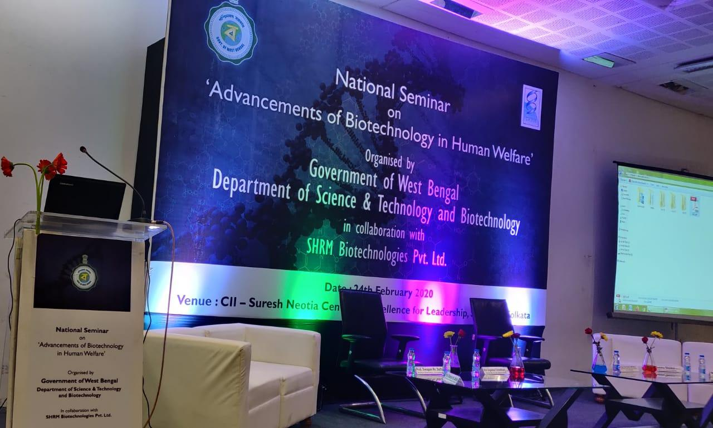
The program started with the welcome address by Honorable Shri. Sajal Kanti Tikadar Joint Scretary, DSTBT,GoWB who welcomed the delegates who were present in that one day seminar.
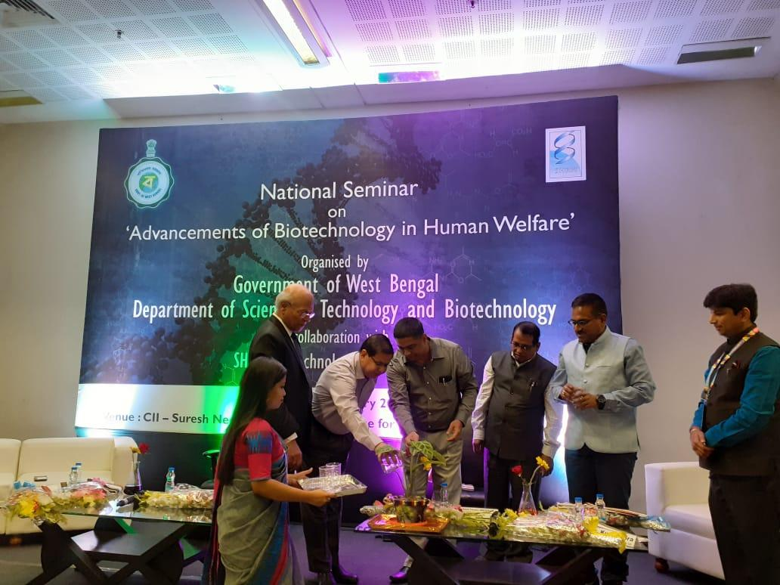

The inaugural session was further preceded by the speech of Honourable Commissioner, DSTBT, GoWB who quoted the words of Nehru “ Small people trying for Big cause” which he described the role of GoWB in exploring the field of Biotechnology in a better way in eastern part of the country.
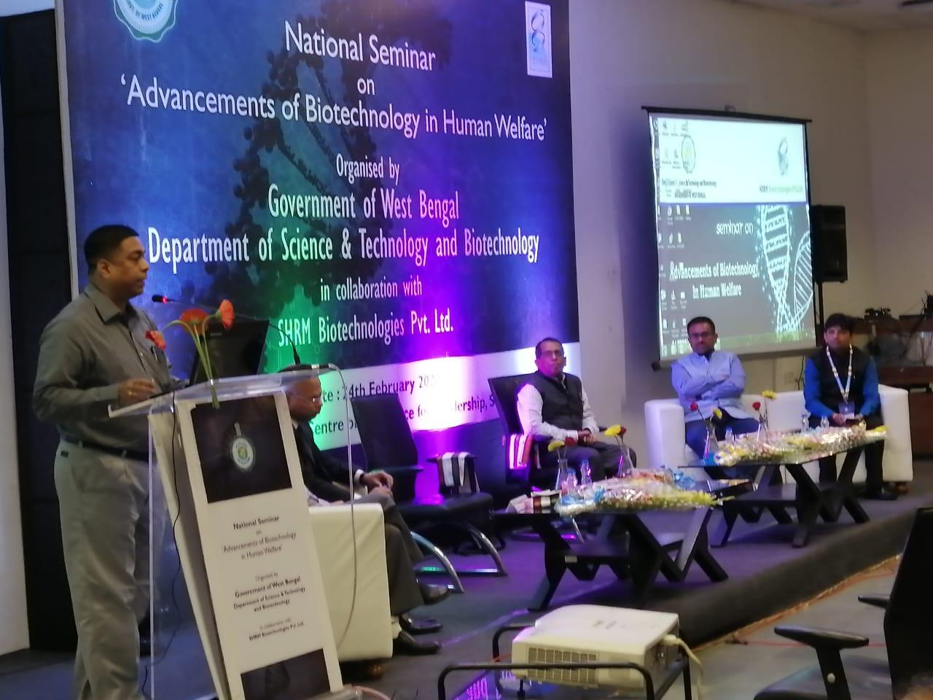
Prof. Swapan Kr. Dutta Ex Vice Chancellor, Viswa Bharati University in his speech mentioned that the starting of Green revolution changed the scenario of biotechnology. He in his benevolent speech mentioned the concepts of genome editing and the use of 5G Intervension.
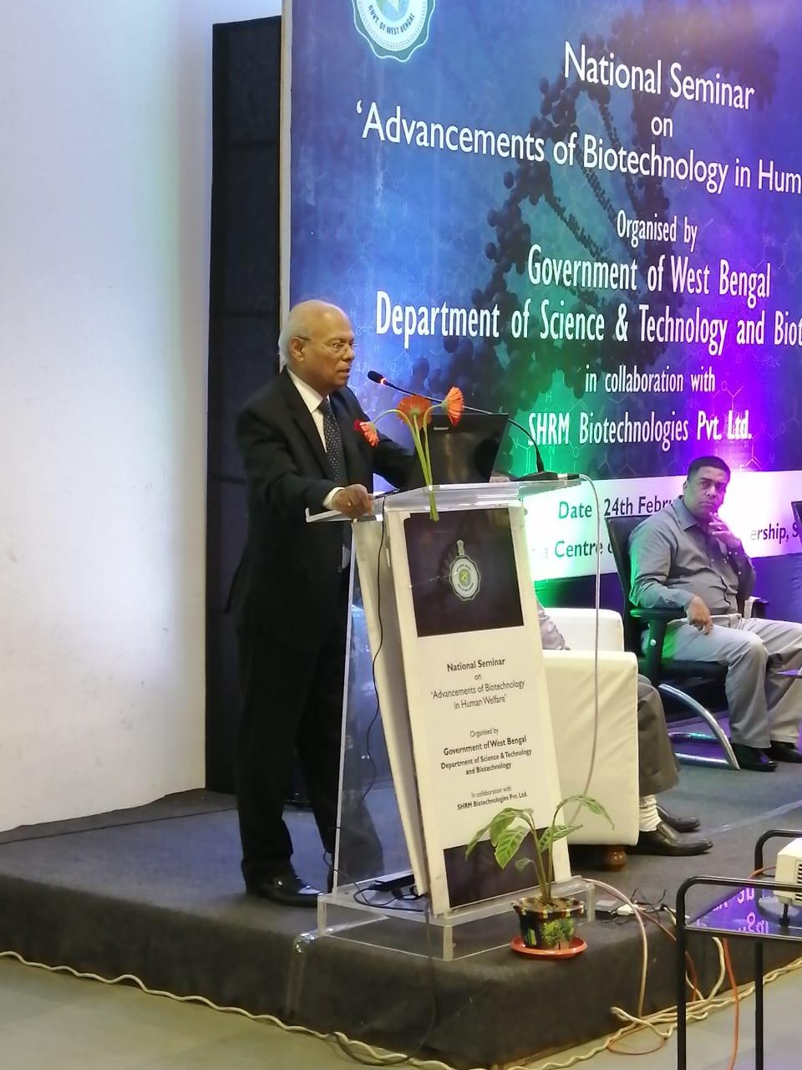

Prof. Shankar Ghosh, Vice Chancellor, Kalyani University in his speech mentioned the Entrepreneurship is the benchmark of development in the field of Biotechnology which is largely fostered by the ecosystem existing between student, industry and academicians.
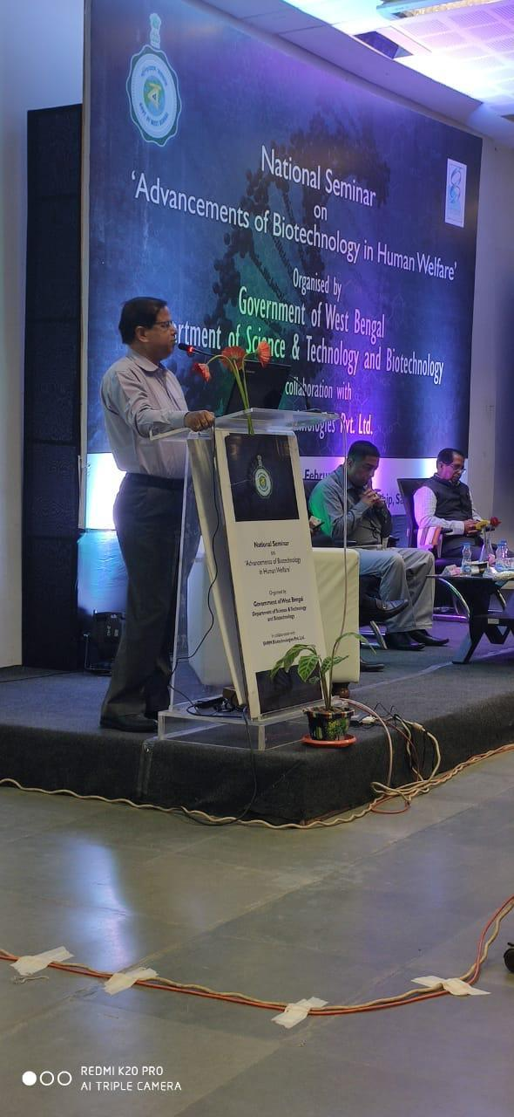
The esteemed delegates’ speech was further supplemented by Shri Kunal Vora, Director, SHRM Biotechnologies Pvt. Ltd who mentioned that advancements in the field of Biotechnology can be properly achieved by the coordination existing between Industry, Government and Academia which will place West Bengal in a newer dimension in the advancement of Biotechnology.
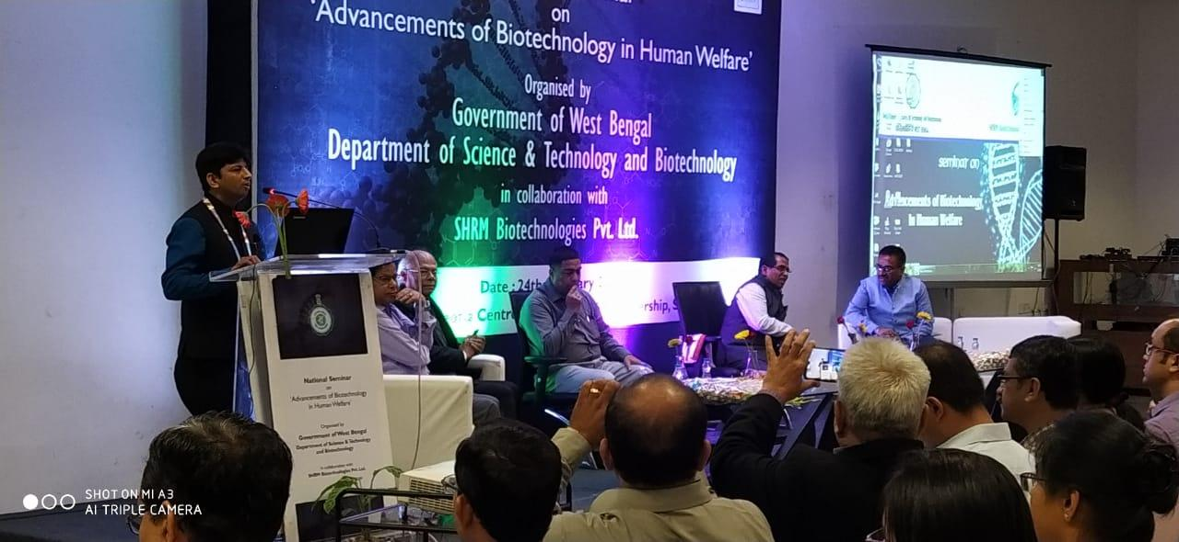

The opening ceremony ended with the speech of Shri Badsha Ghosal, Honorable Deputy Secretary, DSTBT, GoWB who categorically pointed the projects taken up by the Government to popularize Biotechnology among masses. He said the establishment of Biotech Park is a biggest facet that added to the development of Biotechnology in the eastern part of the country.
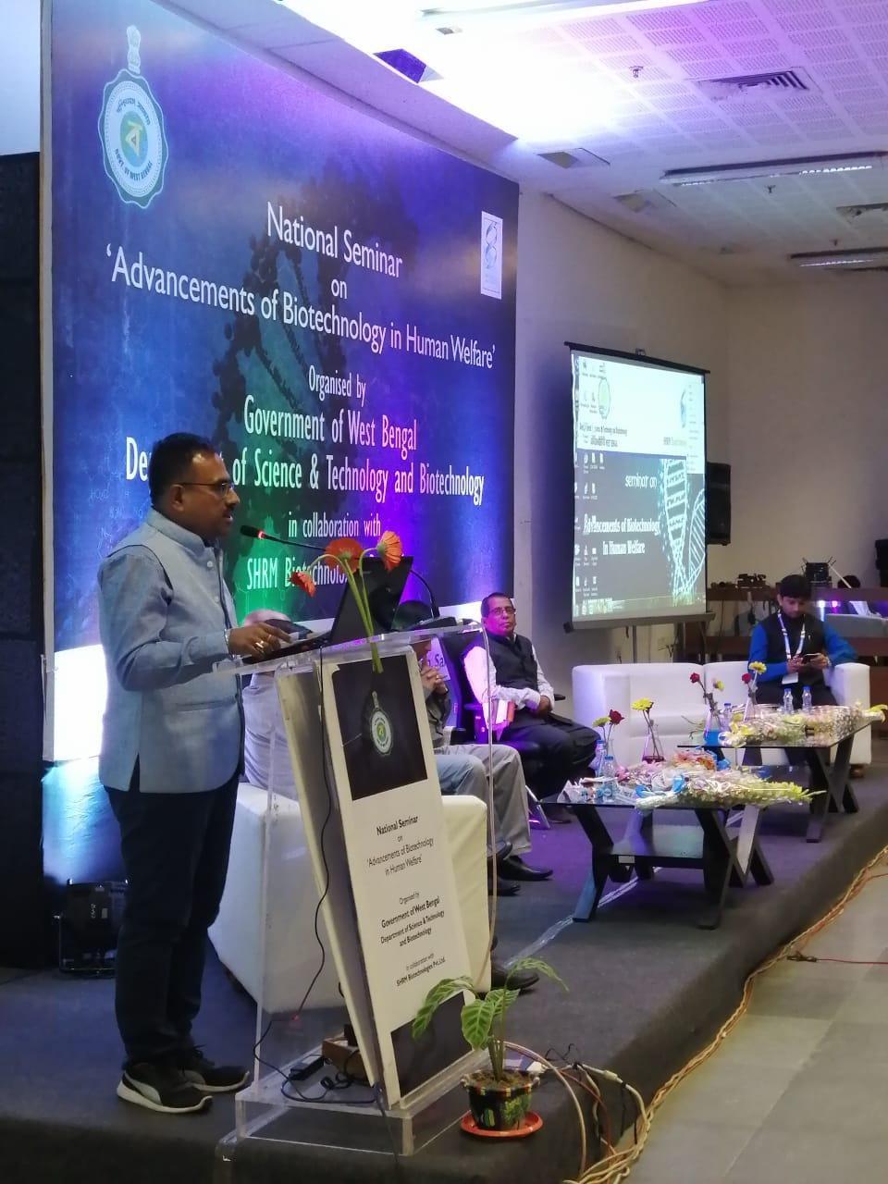

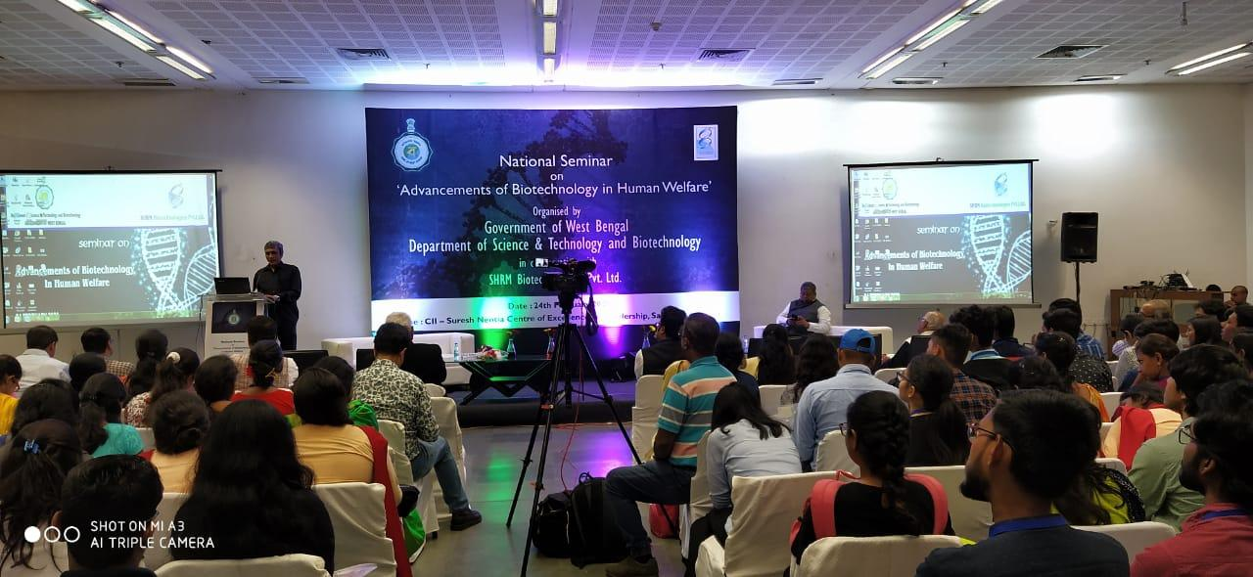

Technical Session 1:
Session Chairperson: Dr. Rinarani Roy, Associate Professor and Head, Department of Biotechnology, Maulana Abul Kalam Azad University of Technology, Haringhata, West Bengal
Lecture 1:Topic: "Plant Kingdom-Cancer Biology-Perfume of Biotechnology Speaker: Dr. Amitava Chattopadhyay, Former Assistant Director, CNCI, Kolkata and Emeritus Professor, Ramakrishna Mission Vivekananda Education Institute
Lecture 2: Topic: Applications of Biotechnology in Cancer Management Speaker: Dr. Susanta Roychoudhury, Chief, Basic Research Saroj Gupta Cancer Centre and Research Institute, Kolkata, Former Chief Scientist, CSIR- Indian Institute of Chemical Biology, Former Professor, Academy of Scientific and Innovative Research (AcSIR) President, Indian Association for Cancer Research
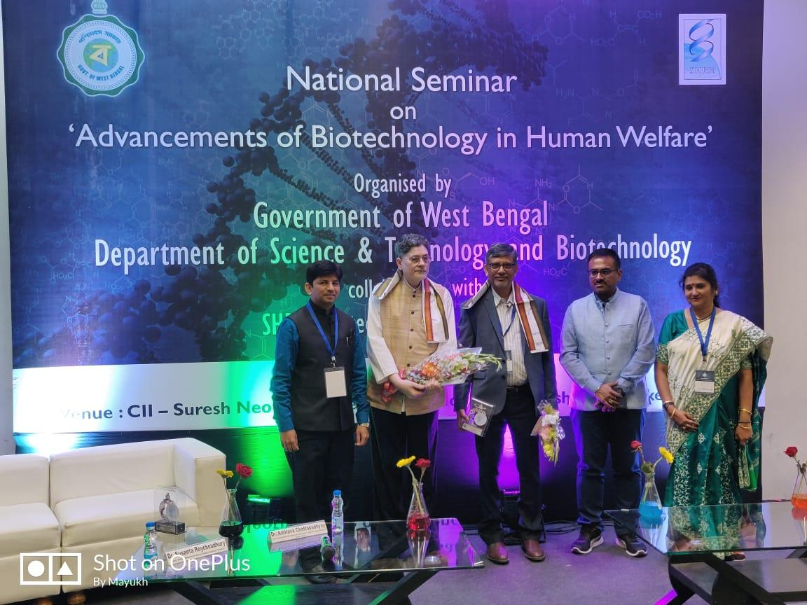

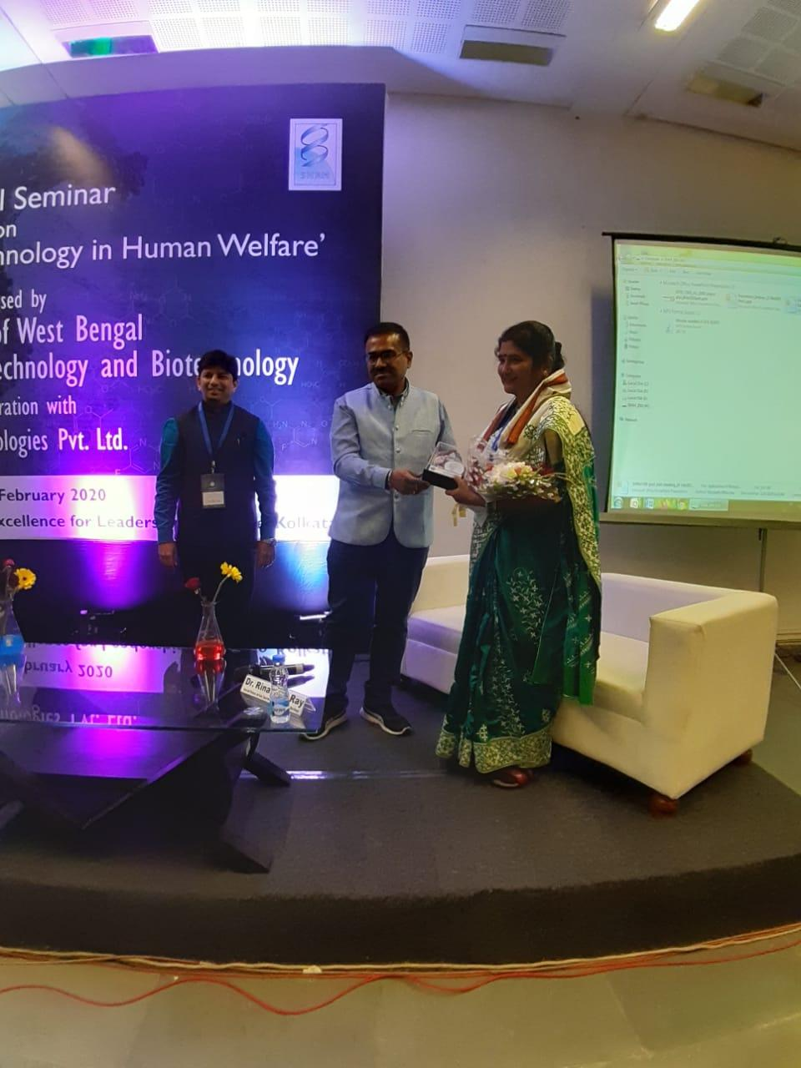
Dr. Rinarani Roy, Associate Professor and Head, Department of Biotechnology, Maulana Abul Kalam Azad University of Technology, Haringhata, West Bengal
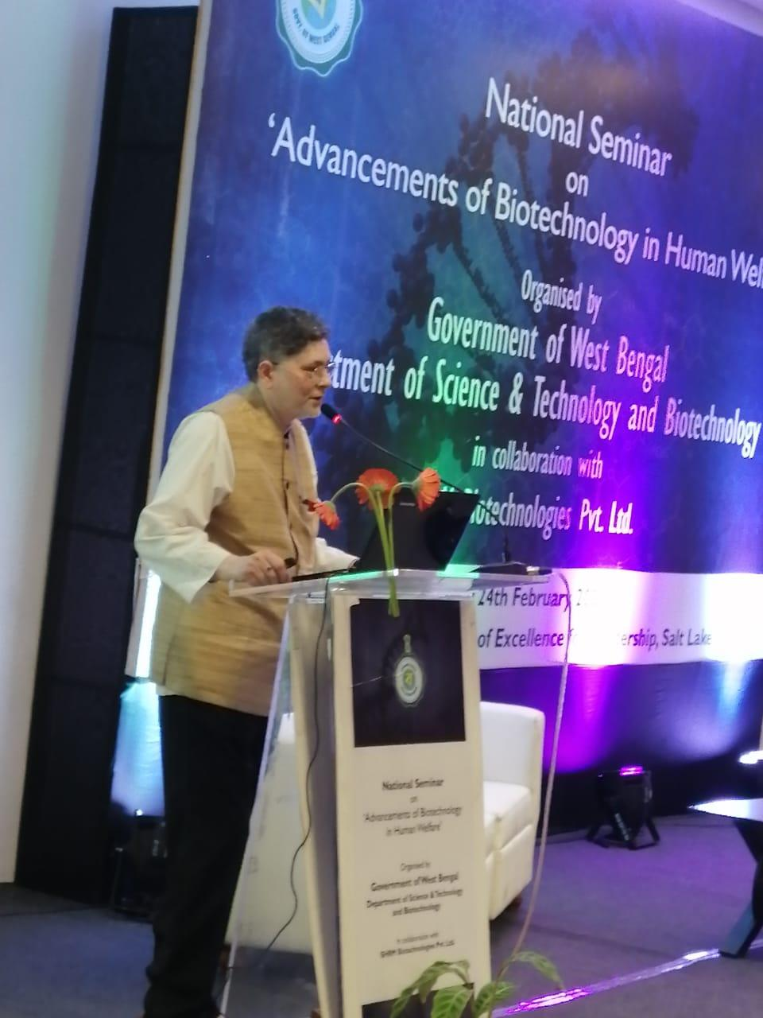
Lecture 1:Topic: "Plant Kingdom-Cancer Biology-Perfume of Biotechnology Speaker: Dr. Amitava Chattopadhyay, Former Assistant Director, CNCI, Kolkata and Emeritus Professor, Ramakrishna Mission Vivekananda Education Institute
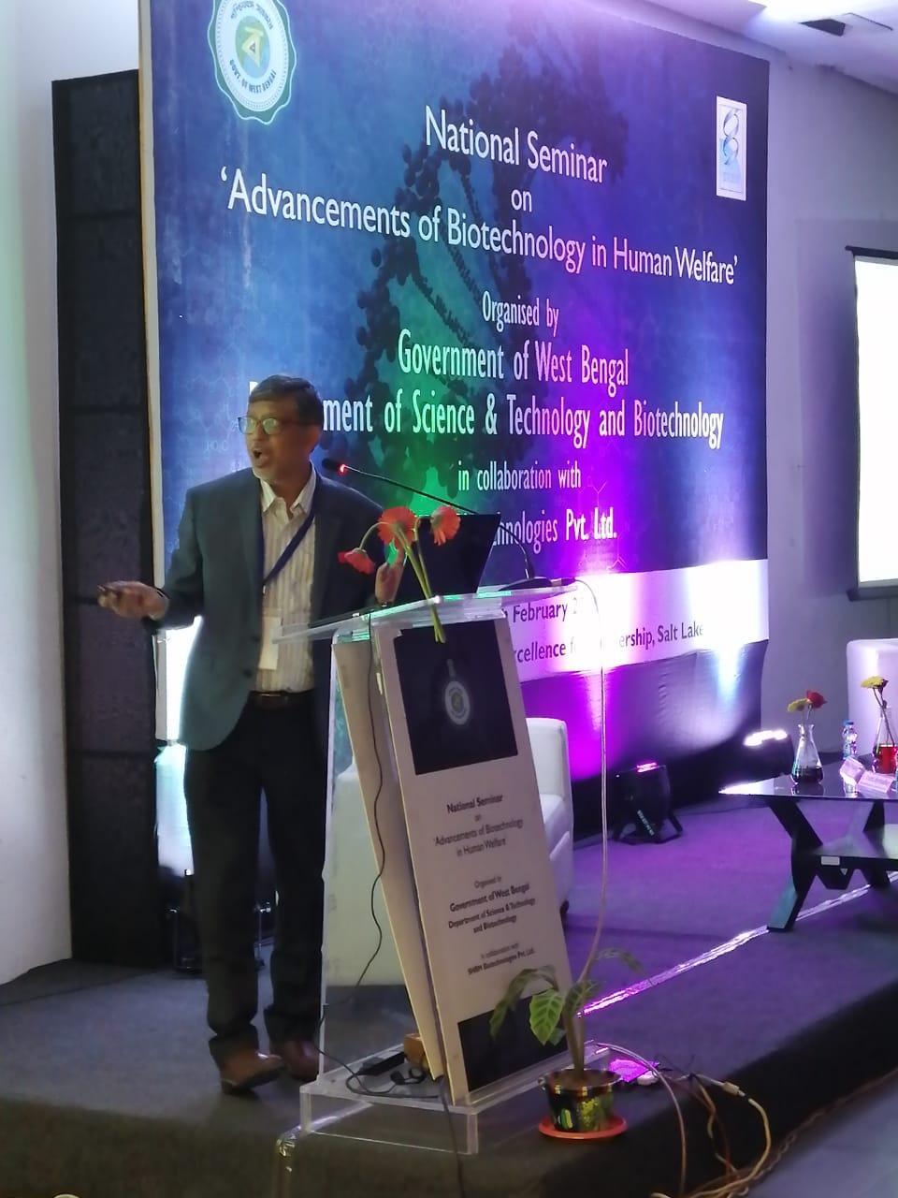
Lecture 2: Topic: Applications of Biotechnology in Cancer Management Speaker: Dr. Susanta Roychoudhury, Chief, Basic Research Saroj Gupta Cancer Centre and Research Institute, Kolkata, Former Chief Scientist, CSIR- Indian Institute of Chemical Biology, Former Professor, Academy of Scientific and Innovative Research (AcSIR) President, Indian Association for Cancer Research

Technical Session 2:
Session Chairperson: Dr. Susmita Mukherjee, Professor and Head, Department of Biotechnology, University of Engineering & Management, Kolkata
Lecture 1: Topic: Immunotherapy of Cancer
Speaker: Dr. Gaurisankar Sa, Professor, Division of Molecular Medicine, Bose Institute, Kolkata
Lecture 2: Topic: An autobiography of D NA – the Beautiful Molecule of Life
Speaker: Dr. Sujoy Dasgupta, Professor, Department of Microbiology, Bose Institute, Kolkata
Lecture 3: Ultraviolet radiation induced Limbal epithelial stem/stromal alteration including microenvironment in Eye
Speaker: Dr. Sujata Law, Professor, School of Tropical Medicine, Kolkata
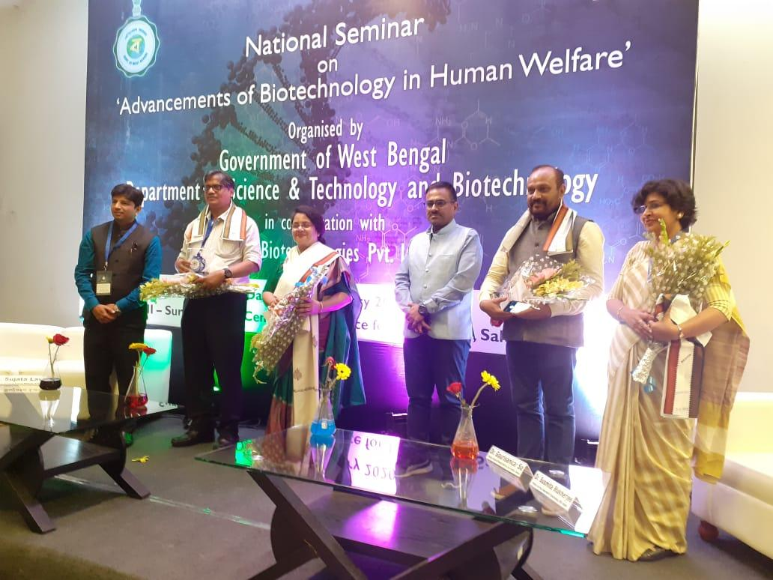
Session Chairperson: Dr. Susmita Mukherjee, Professor and Head, Department of Biotechnology, University of Engineering & Management, Kolkata
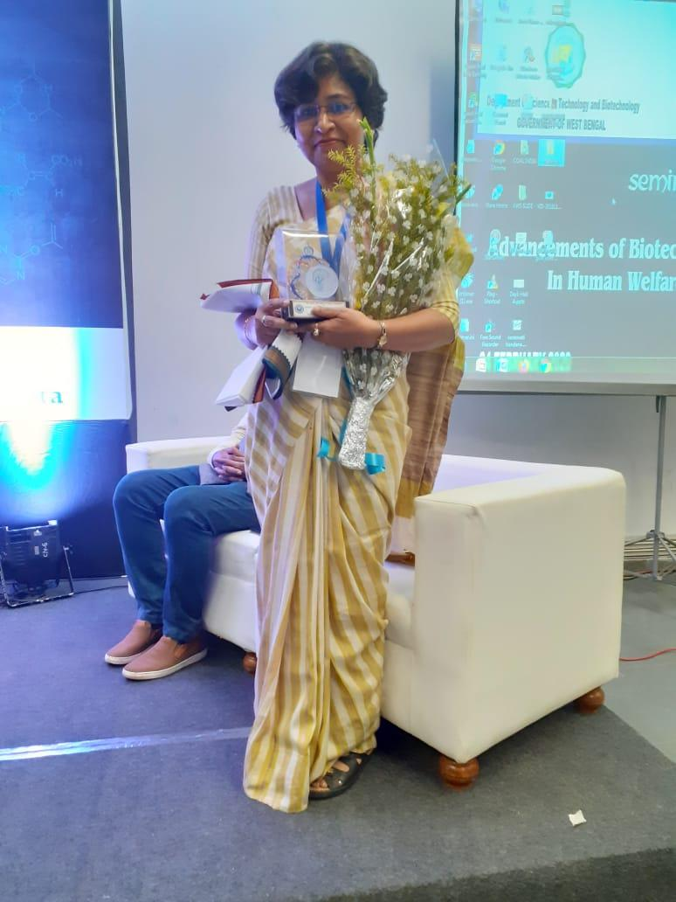

Lecture 1: Topic: Immunotherapy of Cancer
Speaker: Dr. Gaurisankar Sa, Professor, Division of Molecular Medicine, Bose Institute, Kolkata
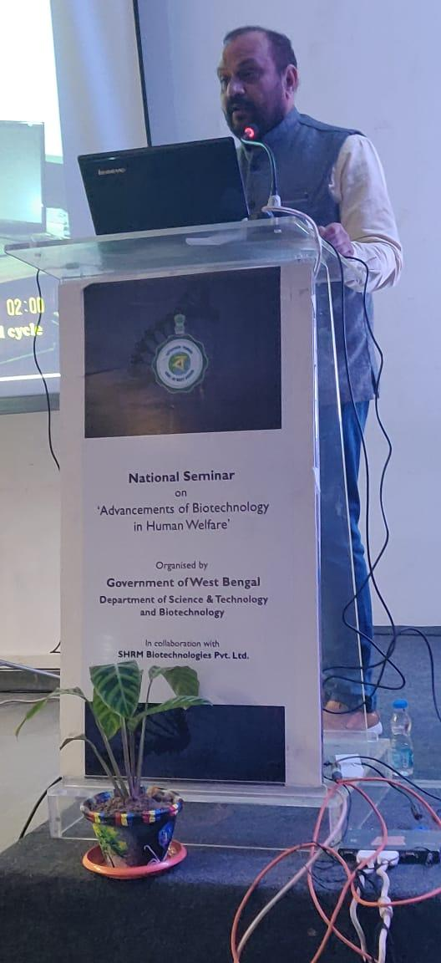

Lecture 2: Topic: An autobiography of D NA – the beautiful molecule of life
Speaker: Dr. Sujoy Dasgupta, Professor, Department of Microbiology, Bose Institute, Kolkata

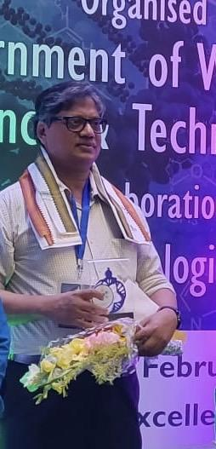

Lecture 3: Ultraviolet radiation induced Limbal epithelial stem/stromal alteration including microenvironment in Eye
Speaker: Dr. Sujata Law, Professor, School of Tropical Medicine, Kolkata
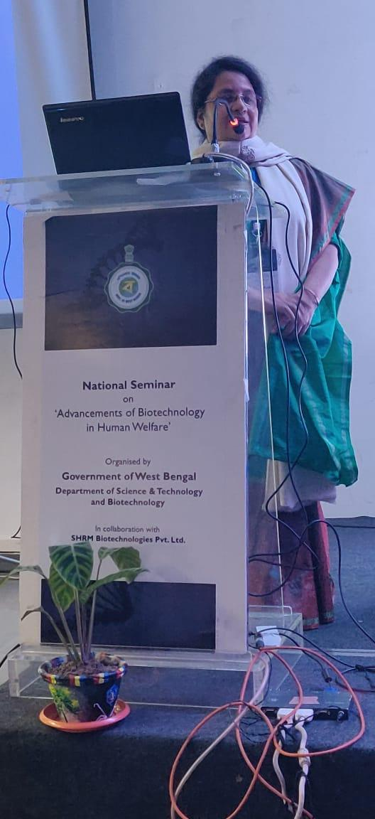

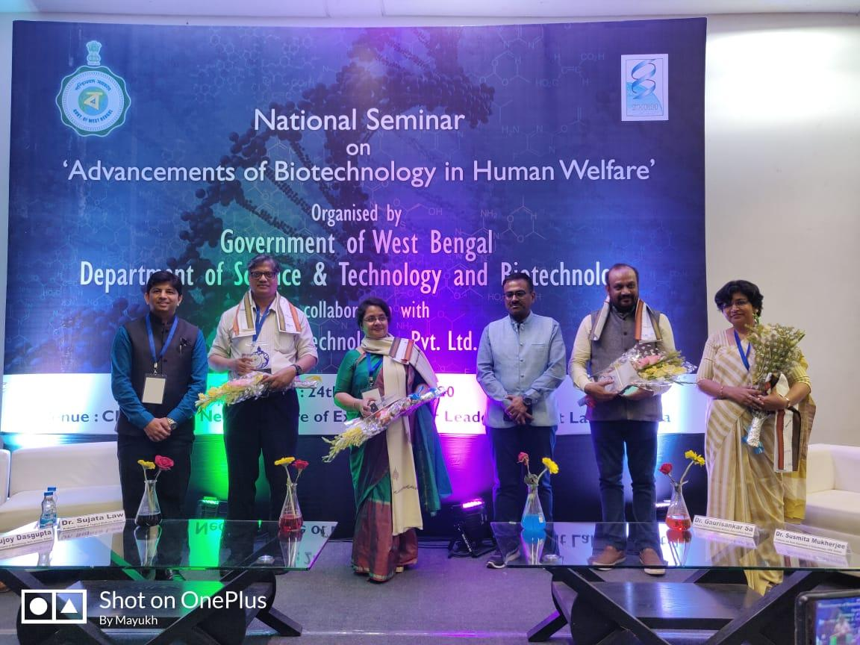

Technical Session 3:
Session Chairperson: Dr. Deborshi De, AVP, SHRM Biotechnologies Pvt. Ltd.
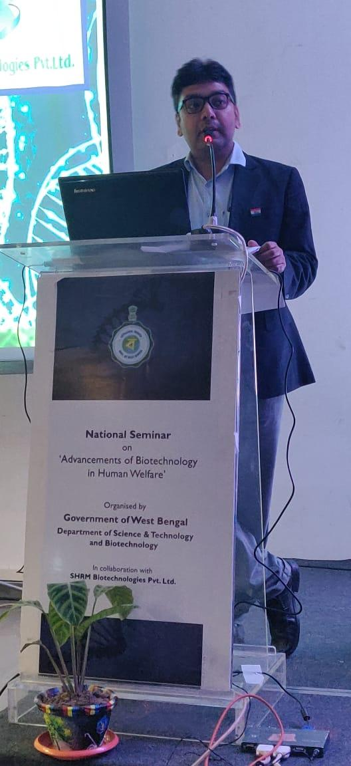

Lecture 1: Topic: Living Drugs in the
Precision Therapy of Human Diseases
Speaker: Dr. Swarup K. Chakrabarti, Director and CEO, Stembionics Pvt. Ltd.
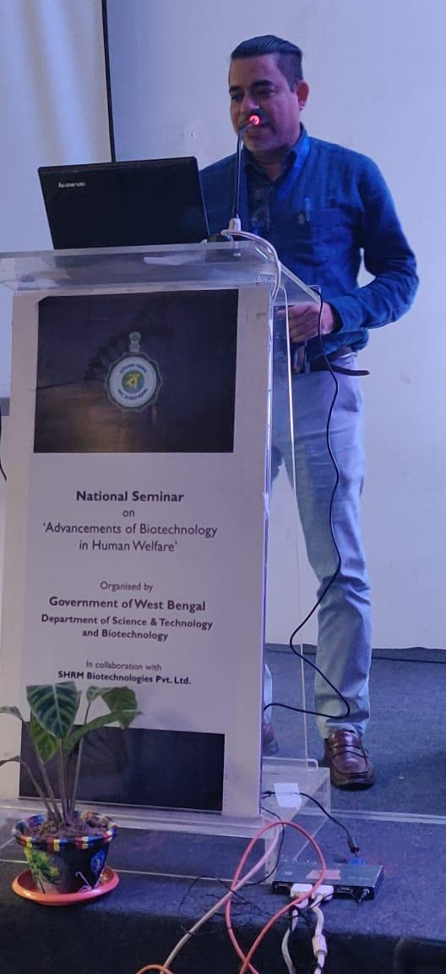

Lecture 2: Topic: Ethics in Agriculture Value Chain to Promote Health
Speaker: Dr. Mukti Sadhan Basu, Former All India Coordinator and Director in ICAR
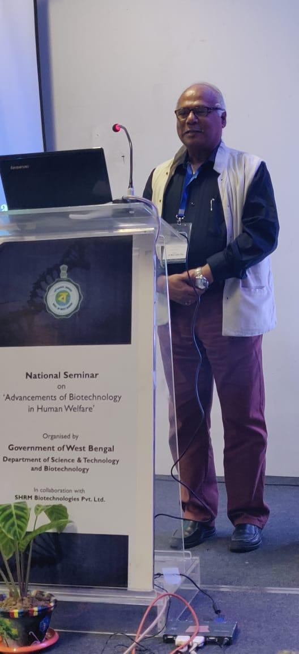

Promotion of IPR Courses by Patent Information Cell, West Bengal State Council of Science and Technology & Maulana Abul Kalam Azad University of Technology, West Bengal
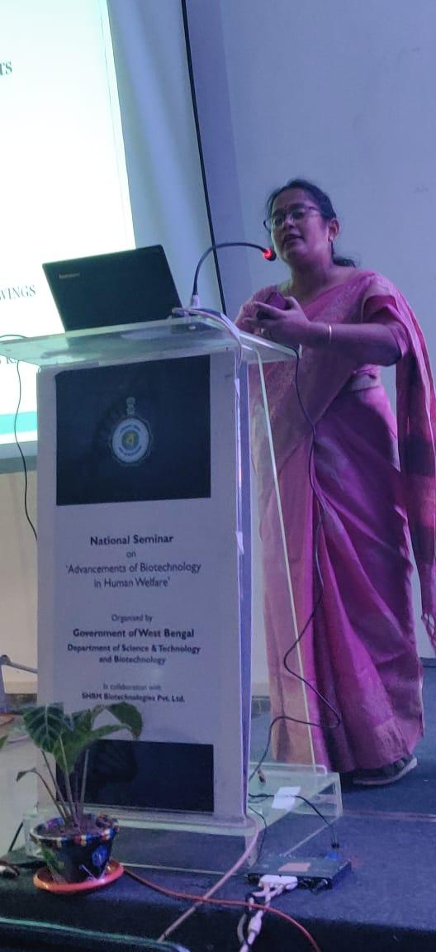
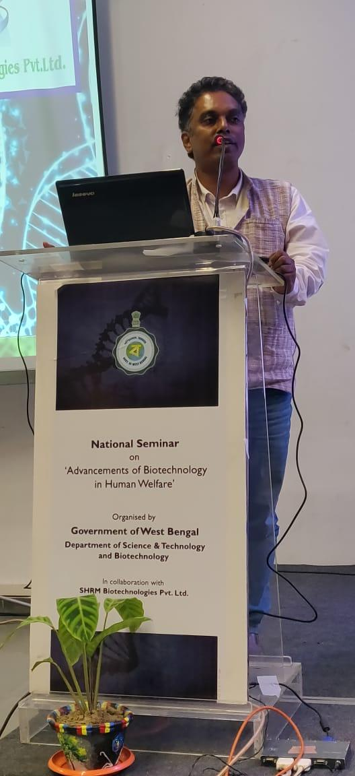

Valedictory Session
The one-day seminar was concluded by the presence of Prof. Saikat Maitra, Honorable Vice Chancellor, MAKAUT and Shri Barun Roy, Honorable Principal Secretary, DSTBT, GoWB. Prof. Maitra mentioned in his concluding speech about the sustainable use of biotechnology in human welfare like bioremediation of heavy metals and degradation of plastics which are the greatest stigma of today’s society. Lastly Shri Ray mentioned that Government would keep doing many such events to popularize the importance of biotechnology among people at large.
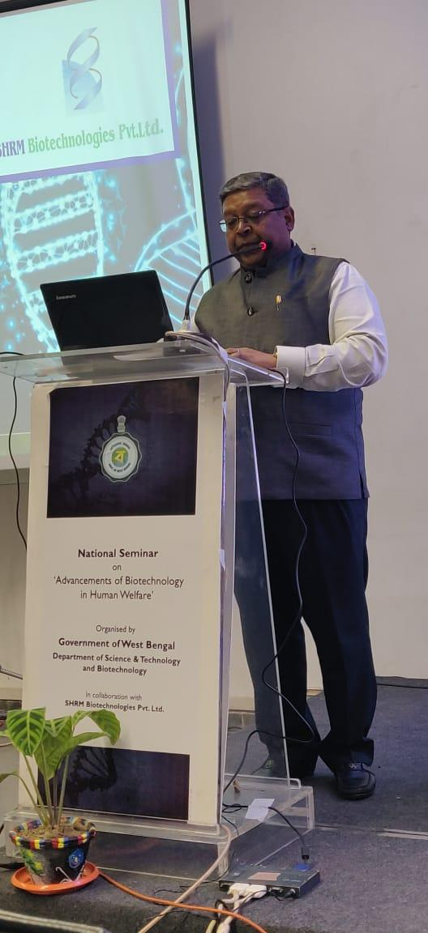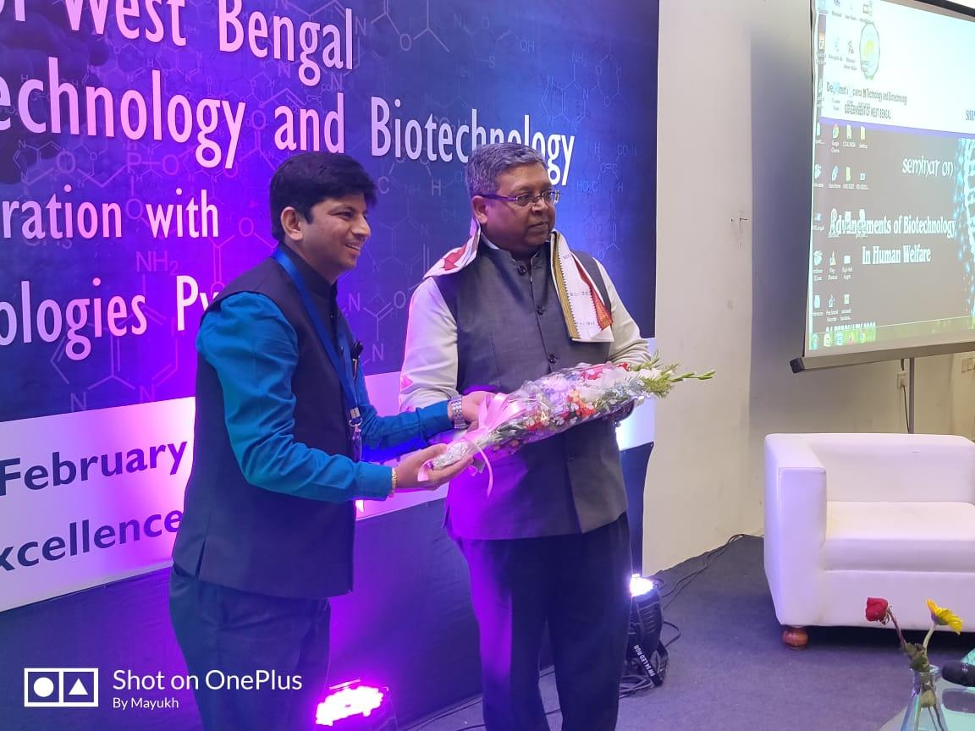
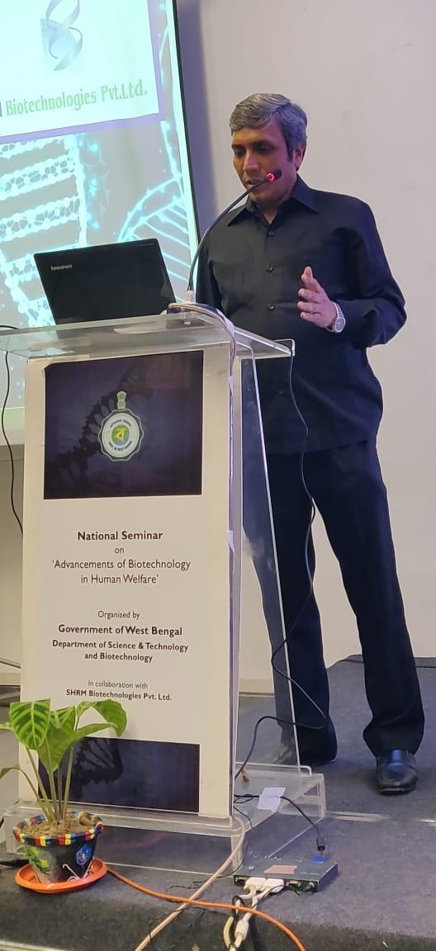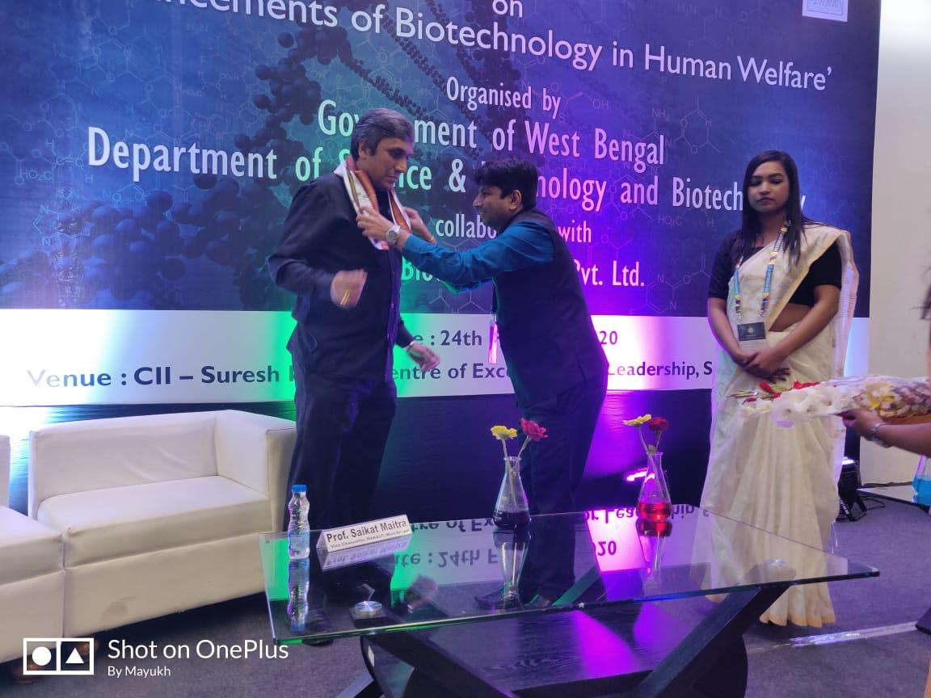

Anchor of the National Seminar: Pallavi Mitra, Research Coordinator, SHRM Biotechnologies Pvt Ltd.

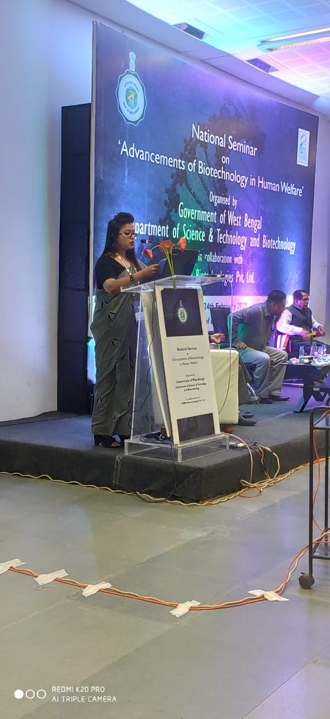

FEEDBACKS
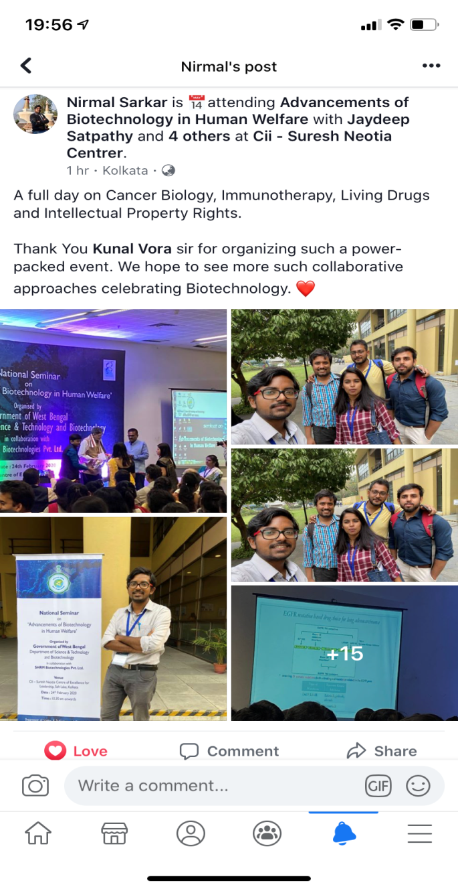
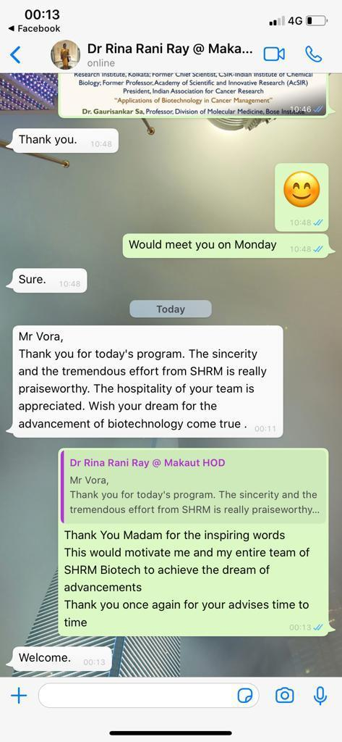

FEW PHOTOGRAPHS
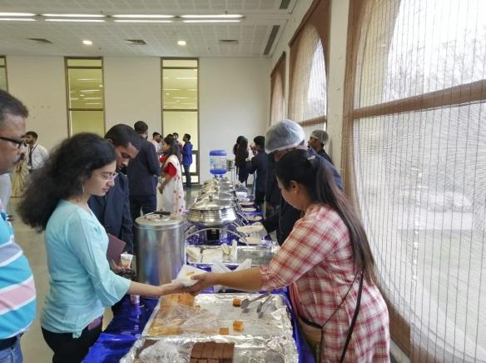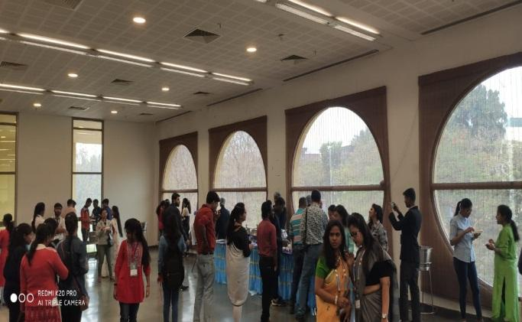
LUNCH SESSION

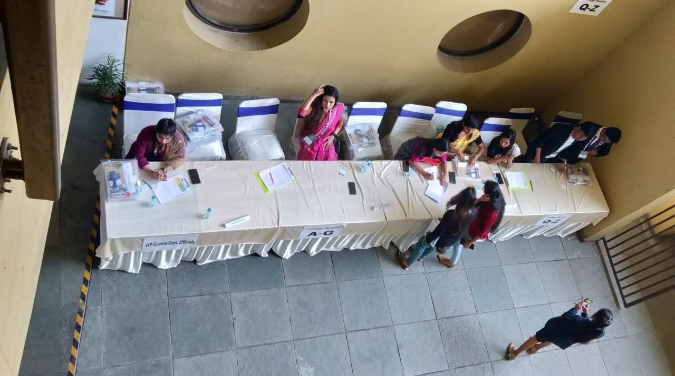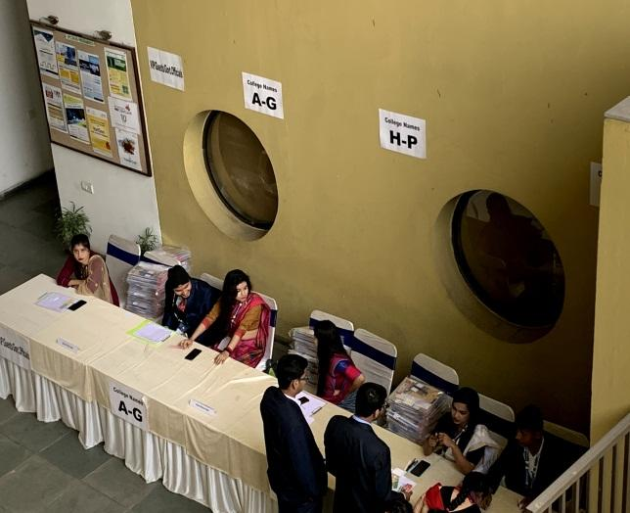
REGISTRATION DESK

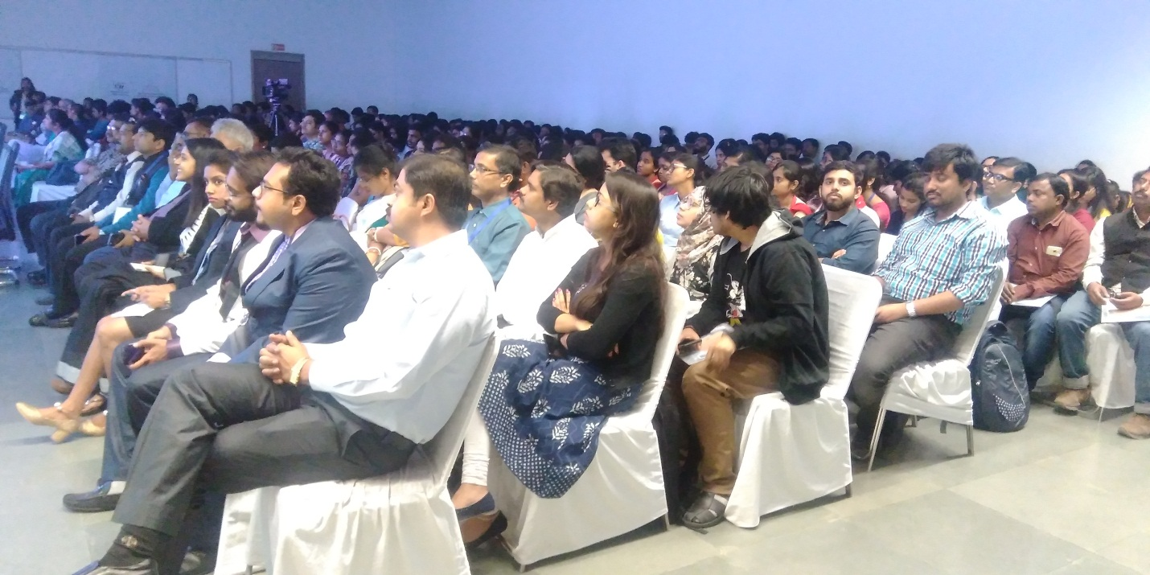
PACKED AUDITORIUM

